Containers
A container is a standardized unit that packages your code and its dependencies. This package is designed to run reliably on any platform, because the container creates its own independent environment.
Eg: Docker
Docker is a popular container runtime that simplifies the management of the entire operating system stack required for container isolation, including networking and storage. Docker helps customers create, package, deploy, and run containers.
Difference between VMs and containers
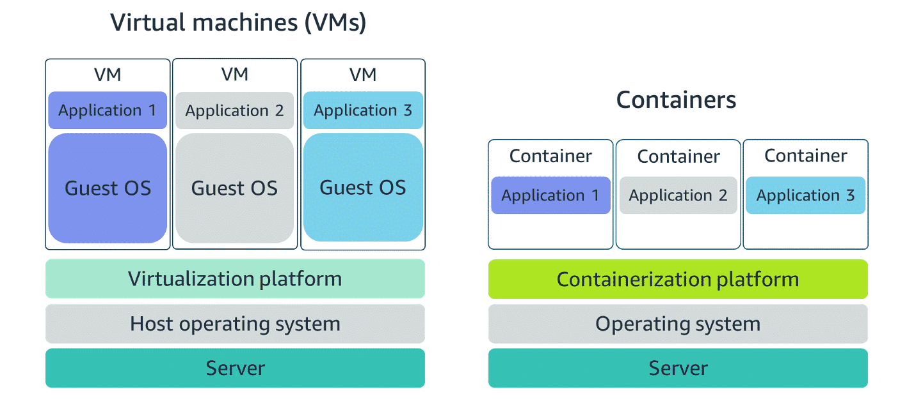

VM | Container
virtual machines contain their own operating system | Containers share the same operating system and kernel as the host that they exist on.
Each virtual machine must maintain a copy of an operating system, which results in a degree of wasted resources. | A container is more lightweight. Containers spin up quicker, almost instantly.
virtual machines offer the full strength of an operating system and more resources, like package installation, dedicated kernel, and more. | Containers can provide speed

Orchestrating containers
Orchestrating containers refers to the automated management of containerized applications — including their deployment, scaling, networking, and lifecycle. When you have many containers running across multiple environments or servers, orchestration tools help ensure everything runs smoothly.
Containers can run on EC2 instances. AWS offers two container orchestration services:
- Amazon Elastic Container Service (Amazon ECS)
- Amazon Elastic Kubernetes Service (Amazon EKS).

Amazone ECS (Amazon Elastic Container Service)

- Amazon ECS is a full container orchestration service by AWS.
- Task Definition is used to define containers for running individual tasks or services.
- Two Deployment Options:
- AWS Fargate – Serverless infrastructure managed by AWS (no server management).
- EC2 Launch Type – Run tasks on user-managed EC2 instances for more control.
- Supports both tasks (one-time or scheduled jobs) and services (long-running apps).
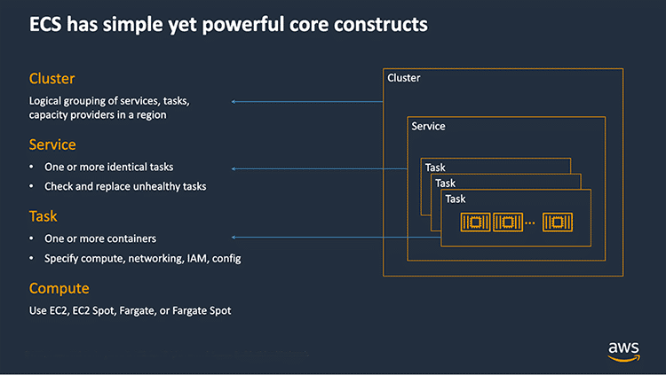
- When using Amazon EC2 instances for ECS, you must install the Amazon ECS container agent on each instance.
- An EC2 instance with this agent is called a container instance.
- The ECS container agent is open source and handles communication with the ECS service for cluster management.
- The agent is compatible with both Linux and Windows AMIs.
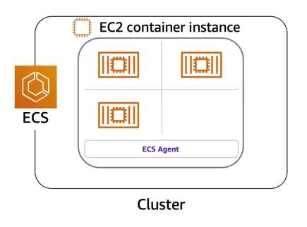

Summary: Preparing an Application for Amazon ECS
- To run an app on Amazon ECS, you must create a task definition.
- A task definition is a JSON-formatted text file that acts as a blueprint for running containers.
- It includes details such as:
  - CPU and memory
  - Container image
  - Ports and networking
  - Storage needs

🧾 Example Task Definition (Breakdown):
{
"family": "webserver", // Task definition name
"containerDefinitions": [
{
"name": "web", // Container name
"image": "nginx", // Container image
"memory": "100", // Container memory (MB)
"cpu": "99" // Container CPU units
}
],
"requiresCompatibilities": [ "FARGATE" ], // Run using AWS Fargate
"networkMode": "awsvpc", // Use VPC networking mode
"memory": "512", // Task-level memory (MB)
"cpu": "256" // Task-level CPU units
}

📝 Notes:
- This task definition is for a corporate directory app using the Nginx web server.
- It's configured to run on AWS Fargate, meaning no EC2 management is required.
- "awsvpc" mode allows each task to get its own elastic network interface (ENI), improving networking control.
Amazon EKS (Amazon Elastic Kubernetes Service)

Kubernetes is an open-source platform for managing containerized applications, combining development and operations in one system. Amazon EKS is a managed service that lets you run Kubernetes on AWS without managing the control plane or nodes yourself.
Compared to Amazon ECS:
- ECS uses EC2 instances with an ECS agent (container instances), while EKS uses Kubernetes worker nodes.
- ECS containers are called tasks, and EKS containers are called pods.
- ECS is AWS-native, whereas EKS is based on Kubernetes.
EKS offers simplicity, high availability, and fine-grained control for users already running Kubernetes workloads.
Resources
(opens in a new tab)For more information, see the following resources:
- AWS website: Containers on AWS(opens in a new tab)
- External website: Docker: Use Containers to Build, Share and Run Your Applications(opens in a new tab)
- AWS website: Amazon Elastic Container Service (Amazon ECS)(opens in a new tab)
- External website: Github: Amazon ECS Agent(opens in a new tab)
- AWS developer guide: Amazon ECS Container Instances(opens in a new tab)
- External website: Coursera course: Building Containerized Applications on AWS(opens in a new tab)
- AWS website: Amazon Elastic Kubernetes Service (EKS)(opens in a new tab)
- AWS user guide: Amazon EKS User Guide

